Clubhouse Handbook
Evidence Based Practices

Disclaimer: Please note that this document is subject to updates and revision. The information is accurate as of the following date: September 3, 2026. Providers should reference the OPOH and the Optum website for the most updated materials.

Overview of Clubhouse Services

Clubhouses are inclusive, community-based environments that support members with behavioral health needs through a voluntary, strength-based approach focused on recovery, empowerment, and community participation. Rather than operating with traditional clinical services, Clubhouses foster a sense of belonging where members are viewed as valued participants rather than patients.

Members and staff work together as equals to build meaningful relationships, develop emotional, cognitive, social, and practical life skills, and contribute to the daily operation of the Clubhouse. Activities are collaboratively designed and carried out by members and staff to meet the needs of the Clubhouse community.

The Clubhouse model emphasizes each member’s strengths, abilities, and potential, while supporting recovery goals related to employment, education, housing, wellness, and community integration. Through participation in a supportive and inclusive environment, members gain opportunities to build skills, increase independence, and improve their overall quality of life.

Delivery of Clubhouse Services

Services are delivered by Clubhouse staff through structured activities organized into the work-ordered day as well as evening and weekend programming. Each Clubhouse has its own policies and expectations designed by members and staff to ensure the space is welcoming and supportive. In addition to the activities described below, most Clubhouses also engage in regularly scheduled meetings where issues are discussed and decisions are made.

- Work-ordered day - Weekdays are structured using a work-ordered day, paralleling business hours (Monday - Friday, 9:00am to 5:00pm) during which members participate in Clubhouse functions using their strengths and talents. During the work-ordered day, members and staff work in collaboration to perform tasks related to Clubhouse functions.

These may include:

    - Administrative functions
    - Meal preparation
    - Cleaning
    - Creating the Clubhouse newsletter and social media updates
    - Organizing the space
    - Performing maintenance
    - Providing employment and educational support
    - Organizing evening, weekend, and holiday programming

- Evening, weekend, and holiday programming- Clubhouses provide structured opportunities for socialization / recreation on evenings, weekends, and holidays when they might otherwise feel alone or isolated.

Activities may include:

  - Cultural activities
  - Recreational activities
  - Excursions
  - Holiday events
  - Continued supported employment and education services

- Employment programs & Education Support- Clubhouses support members in obtaining, restoring or sustaining employment, helping them manage challenges and supporting access to community educational resources and opportunities.

  - Clubhouse staff provide education and employment support directly to members, including finding and maintaining a place in school or work, and support with dealing with challenges that arise in those settings. Clubhouse staff shall provide Transitional Employment (TE) and Supported Employment (SE).

  - IPS is a separate EBP that is available to the system. Clubhouse TE and SE are separate and distinct from IPS. Clubhouses should be able, for the most part, to support members’ employment and educational goals. If needed, IPS will be available for programs to refer members to when their employment/educational needs require the intensive IPS services.

- Linkages to Other Services and Supports- Clubhouse staff should facilitate referrals, warm handoffs, and other linkages for members as needed. Clubhouses should be able to connect members with services and support including:

  - Physical health services
  - Other specialty mental health and SUD services
  - Housing services and supports
  - ECM providers
  - Benefit services
  - Emergency services
  - Social services
  - Self-help/peer-run services
  - Independent living centers

- Housing supports- Clubhouse staff support members in securing and sustaining safe and affordable housing and support them in managing challenges to maintaining housing.

- Reach out services- Clubhouse members and staff reach out to current members who have stopped attending, who are becoming isolated in the community, and who are hospitalized. Clubhouse staff also identify and engage new members who may benefit from Clubhouse services.

Evidence-Based Criteria for Services

Clubhouse Services are typically appropriate for Medi-Cal members with a diagnosis consistent with Serious Mental Illness (SMI) or co-occurring SMI and Substance Use Disorders (SUD), according to current DSM and the International Statistical Classification of Diseases and Related Health Problems criteria and as determined by a clinician. In many cases, a member may also have significant functional impairment, which may include one (1) or more of the following:

- Inability to perform skills needed for basic independent functioning in the community.

- Recurring trouble with performing activities of daily living without assistance.

- Inability to maintain self-sustaining employment

- Difficulty carrying out responsibilities to maintain one’s household or a safe living environment.

Clubhouse Services are not appropriate for members solely diagnosed with SUD, I/DD, or psychosis induced by a medical condition.

New members may be already connected to additional mental health supports throughout the County such as Outpatient, ACT or case management, but it is not required. New members must meet medical necessity to participate in the clubhouse benefit. An overview of medical necessity is described in the section below.

Medical Necessity
(Definition CalMHSA Doc Guide- pg. 7)

A person qualifies for Specialty Mental Health Services (SMHS) if they have a mental health condition (or are at risk of developing one) and the condition causes problems in important areas of life such as work, school, family relationships, daily functioning, housing stability, or personal safety. Once a person qualifies for SMHS, the provider must determine whether clubhouse services are reasonable and necessary for that particular member.

As a clubhouse staff, it can be helpful to ask yourself:

- Does this person have a mental health condition (or risk factors) that is affecting their life?

- Will the services provided by the clubhouse help prevent the person's mental health condition from getting significantly worse and/or help them function more safely and effectively?

Throughout all documentation it is very important to demonstrate why the member’s engagement with the clubhouse and its activities are beneficial to improving their well-being and/or prevent symptoms from getting worse.

Example: John struggles with depression. He has a hard time finding motivation to get out of bed and feels “down” all the time. John states that the clubhouse gives him a reason to get out of bed every day. He has made connections with other members who he looks forward to seeing on a daily basis. Without the clubhouse, John believes his symptoms of depression would become much worse.

The above example is a simple overall explanation of “medical necessity”. Service notes should document how the intervention or service will address the client’s identified behavioral health needs alongside meeting criteria for continued services.

In a note this might look like the following:

John participated in a social activity today. John reported that he felt “less empty” after talking with another member. Staff will continue to encourage John to participate in social activities to work towards one of his goals of “making more friends”.

Medical Necessity Criteria (BHIN 26-002)

Access Criteria for Members Age Twenty- One (21) or Older

Must meet both of the following (1 and 2):

- One (1) or both of the following:

  - Significant impairment (i.e. distress, disability, or dysfunction in social, occupational, or other important activities). AND/OR

  - A reasonable probability of significant deterioration in an important area of life functioning.

- The member’s condition is due to either of the following:

  - A diagnosed mental health disorder OR

  - A suspected mental health disorder

Access Criteria for Members Under Age Twenty- One (21)

Must meet either of the following (1 or 2):

- Scoring in the high-risk range under a trauma screening tool approved by the department, involvement in the child welfare system, juvenile justice involvement, or experiencing homelessness. OR

- The member meets both of the following requirements in a and b:

a. The member has at least one (1) of the following:

- A significant impairment.

- A reasonable probability of significant deterioration in an important area of life functioning.

- A reasonable probability of not progressing developmentally as appropriate.

- A need for SMHS, regardless of presence of impairment, that are not included within the mental health benefits that a Medi-Cal Managed Care Plan (MCP) is required to provide.

AND

b. The member’s condition as described in 2 above is due to one (1) of the following:

- A diagnosed mental health disorder, according to the criteria of the current editions of the DSM and the ICD.

- A suspected mental health disorder that has not yet been diagnosed.

- Significant trauma placing the member at risk of a future mental health condition, based on the assessment of a licensed mental health professional.

Staffing

Clubhouse Services are delivered by a staff of behavioral health practitioners trained in the Clubhouse model. Staffing levels are purposefully kept low to ensure there is a need for the active involvement of the members. The role of the staff in a Clubhouse is not to educate or treat the members, but to engage in work alongside them and support increased autonomy.

Medi-Cal behavioral health staff that work in a Clubhouse include licensed mental health professionals, mental health rehabilitation specialists (MHRS), physician assistants (PA), pharmacists, other qualified providers, medical assistants (MA), clinical trainees and counselors. A typical Clubhouse will include at least four (4) staff, including one (1) Clubhouse director and other mental health practitioners with training in the Clubhouse model. Staffing should be adjusted accordingly as part of the ongoing Accreditation process. Clubhouses generally support a ratio of four and a half (4.5) daily members to one (1) staff, or eighteen (18) active members to one (1) staff.

While Clubhouses are not required to have an LPHA on staff, Clubhouse Services covered by Medi-Cal must be provided by or under the direction of a licensed professional functioning within the scope of their professional license and applicable state law: a physician; a licensed / waivered psychologist; a licensed/waivered / registered social worker; a licensed/waivered / registered marriage and family therapist; a licensed/ waivered registered professional clinical counselor; a registered nurse (including a certified nurse specialist, or a nurse practitioner); or a licensed occupational therapist.

Head of Service: DEFINITIONS OF HEAD OF SERVICE PER CALIFORNIA CODE OF REGULATIONS, TITLE 9

Definitions of Credentials:

- LPHA: Licensed Practitioner of the Healing Arts: Physician, Nurse Practitioner (NP), Physician Assistant (PA), Registered Nurse, Registered Pharmacist, Licensed Clinical Psychologist (LCP), Licensed Clinical Social Worker (LCSW), Registered CSW, Licensed Professional Clinical Counselor (LPCC), Registered PCC, Licensed Marriage and Family Therapist (LMFT), Registered MFT, Licensed Vocational Nurse (LVN), Licensed Occupational Therapist (LOT), and Licensed Psychiatric Technician (LPT)

- Scope of practice refers to those activities that a person licensed to practice as a health professional is permitted to perform, which is increasingly determined by statutes enacted by state legislatures and by rules adopted by the licensing entity. Please utilize the link/table to determine services within scope of practice for different staff: Scope of Practice (CALMHSA Documentation Guide- Appendix III (pg. 39)
- Waivered: a person who was hired from outside California, whose experience is sufficient to gain admission to the appropriate licensing examination and who has been granted a professional licensing waiver approved by the Department of Health Care Services to the extent authorized under state law.

Accreditation

For BHPs to bill Medi-Cal for Clubhouse Services, Clubhouses must work with Clubhouse International to achieve Clubhouse International Accreditation. Accreditation is a researched-based, quality assurance program to ensure Clubhouses are operating effectively and in alignment with the Clubhouse Quality Standards. BHPs may bill Medi-Cal for Clubhouse Services for up to one (1) year before a Clubhouse begins the Accreditation process, and for up to three (3) years while the Clubhouse is actively pursuing Accreditation.

Standards are reviewed every two (2) years by Clubhouse International’s Standards Review Committee, and include:

- Participation is fully voluntary and members can access all the opportunities available to them through Clubhouses.

- Relationships describe the relationship between Clubhouse staff and members.

- Space emphasizes the importance of creating a dignified, attractive environment where work is carried out.

- Work-Ordered Day describes the structure of the day-to-day activity within a Clubhouse, organized to help members develop self-esteem, confidence, and friendships.

- Employment ensures that Clubhouses offer members organized, effective strategies for moving into and maintaining gainful employment.

- Education ensures that Clubhouses offer members opportunities to complete their education

- Functions of the House address the basic requirements for meeting members’ needs, with an emphasis on social and healthcare services.

- Funding, Governance, and Administration describes requirements for overseeing and managing Clubhouses.

Billing & Medi-Cal Payment

Services delivered by Clubhouses that meet the requirements in BHIN 25-009 may be paid using a county-specified, daily bundled rate. County-specific rates for behavioral health services are posted on the Medi-Cal Behavioral Health Fee Schedule.
BHPs cannot claim for any unbundled Clubhouse services in addition to the daily bundled rate.

- Bundled rate = at least three (3) hours of face-to-face in person services per day

- Please note that at this time there is nothing indicating that the hours of service per day MUST be consecutive. This means that the member can leave and come back to the clubhouse as long as the total time they are present is at least three (3) hours. Staff would need to make sure at least one (1) note is present for the day and indicate on the note or in the body of the note the different times the member was present at the clubhouse.

- Eligible Providers of Clubhouse Services are paid a Full-Day rate when the member participates in Clubhouse Services for at least three (3) hours. (HCPCS Code H2031)

Staff will enter all service notes as non-billable notes in SmartCare. It is very important that the member time in and time out of the clubhouse is documented in order to justify the three (3) hour requirement for billing. Billing staff will enter the bundled rate via an administrative entry process: Optum Website> SMH & DMC-ODS Health Plans> MH Resources> Clubhouse Services> Clubhouse Day Rate Service Entry

Verifying Medi-Cal Eligibility
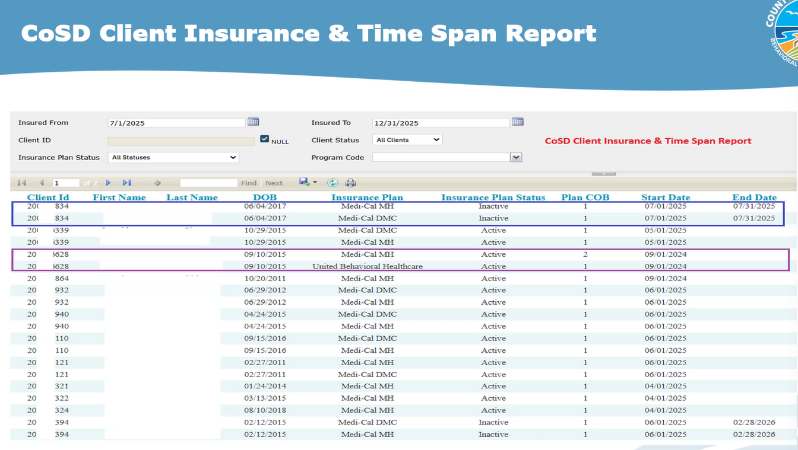
Specialty mental health clients must be enrolled in Medi-Cal for the BHP to be reimbursed through the SD/MC claiming system. BHPs should verify member Medi-Cal eligibility for the month of service prior to submitting claims for reimbursement.
Use the links below to read about how to enroll in the provider portal to determine member Medi-Cal eligibility.

- Registering to Verify Eligibility on the Medi-Cal Provider Portal
- DHCS - Provider Portal

UMDAP Financial Assessment
UMDAP Financial Assessment (Client)

Medi-Cal offers health care coverage to individuals and families whose income exceeds the maximum allowable by requiring these members to contribute to their health care by paying a share of the cost for the services they received. UMDAP was developed to establish a statewide method of determining the ability of the client or financially responsible person to personally contribute to covering the cost of specialty mental health services received. The State requires counties to apply the Uniform Method of Determining Ability to Pay (UMDAP) during financial screening, which includes a standard sliding scale fee to determine the member’s liability amount.

Timeline: The UMDAP annual charge period is valid for a period of (1) year

If a member refuses to sign the UMDAP: A member is considered to be “Full Pay” if he/she does not respond to request for financial information or refuses to provide financial information or verification, if requested. This is recorded by not placing a checkmark in the box for the financial information provided/verified and entering R= not provided/refused in the reason list.

Resources: UMDAP Financial Assessment in SmartCare.pdf

SmartCare Client Plan Request Form

Programs are required to complete this plan request form and submit it to the BHS Billing Unit (MHBillingUnit.BHS@sdcounty.ca.gov )for members who have a primary health plan that needs to be added to their coverage plan in SmartCare.
This form is required for:
- New clients in the system of care
- Members who do not have any active insurance plans in SmartCare
- Members whose coverage changes or expires
Resources:
- Guidelines_on_Completing_the_SmartCare_Client_Plan_Request_Form.pdf
- SMH & DMC-ODS Health Plans > SmartCare Tab> Billing> SmartCare Client Plan Request

EBP Required Components of Programming

Clubhouse providers must provide at least one (1) of the following Clubhouse Service components during a face-to-face encounter with a member to be paid a bundled rate.

- Employment and Education Support Services
- Medication Support Services
- Psychosocial Rehabilitation
- Referral and Linkages
- Treatment Planning

Definitions:

- Employment and Education Support Services- providing a service through which members learn coping mechanisms and problem-solving skills to work towards their goals. These services aim to help members find and maintain employment and support educational goals that lead to job readiness.
:
Examples:
  - Assisting a member with creating or updating a resume.

  - Helping a member complete online job applications.

  - Practicing interview skills through mock interviews.

  - Supporting a member in enrolling in community college or vocational training.

  - Assisting a member with completing financial aid paperwork.

  - Helping a member develop a weekly schedule to balance school, work, and recovery activities.

  - Providing support to a member participating in a Transitional Employment placement through the Clubhouse.

  - Coaching a member on workplace communication and conflict resolution skills.
Example Note Language: Staff assisted with identifying employment interests and updating their resume. Member practiced discussing work experience and strengths to increase confidence in seeking employment.
- Medication Support Services- Medication support in clubhouses is not a standalone service but part of a broader recovery ecosystem. It combines peer support, clinical coordination, and community integration to help members manage their medications effectively, improve adherence, and reduce the risk of hospitalization. Clubhouses may offer reminders, pill organizers, and accountability check-ins to help members stay on track with their medication schedules. By creating a supportive, non-judgmental environment, clubhouses help reduce stigma around taking medication, which can improve willingness to follow treatment plans.

Examples:

  - Reminding a member of an upcoming psychiatry appointment.

  - Helping a member organize questions for their prescriber.

  - Assisting a member in understanding medication instructions provided by their psychiatrist.

  - Supporting a member in tracking medication adherence using a calendar or phone app.

  - Discussing barriers to obtaining medications and helping identify solutions.

  - Coordinating with the member's treatment team regarding medication concerns reported by the member.

  - Assisting a member with arranging transportation to a medication management appointment.

Example Note Language: Staff supported member in preparing for an upcoming psychiatric appointment by reviewing medication concerns and helping member develop questions to discuss with their prescriber.

- Psychosocial Rehabilitation- This service aids in restoring, improving, and/or preserving a member’s functional, social, communication, or daily living skills to enhance self-sufficiency or self-regulation in life domains (i.e. home, work school, etc.). It includes interventions that utilize self-expression such as art, recreation, dance or music as a modality to develop or enhance skills.

  - These therapeutic interventions assist the member in attaining or restoring skills which enhance community functioning including problem solving, organization of thoughts and materials, and verbalization of ideas and feelings.

  - May also include support resources, medication education, and/or psychoeducation.

  - May include contact with significant support persons or other collaterals if the purpose of their participation is to focus on the treatment needs of the member. Psychosocial rehabilitation may be provided to a member or a group of members.

Examples:

  - Participating in the culinary unit to build daily living and social skills.

  - Working in the reception area to improve communication and organizational skills.

  - Participating in a wellness activity focused on coping skills and stress management.

  - Practicing social interactions during the work-ordered day.

  - Learning time management skills through completion of Clubhouse responsibilities.

  - Developing problem-solving skills while planning a member event.

  - Building confidence through leadership opportunities within the Clubhouse.

  - Participating in community outings to increase community integration and reduce isolation.

Example Note Language: Member participated in the culinary unit and collaborated with peers to prepare lunch. Staff provided coaching and encouragement to support communication skills and increase social engagement.

- Treatment Planning - A service activity to develop or update a member’s course of treatment, documentation of the recommended course of treatment, and monitoring of a member’s progress.

Examples:
  - Meeting with a member to identify recovery goals related to employment, education, housing, or social functioning.

  - Reviewing progress toward treatment goals.

  - Updating goals based on the member's current needs and preferences.

  - Identifying barriers that are affecting the member's recovery.

  - Discussing services and supports that would help the member achieve their goals.

  - Reviewing strengths that can support recovery progress.
Example Note Language: Staff met with member to review progress toward their goal of obtaining employment. Member identified increased confidence in applying for jobs and expressed interest in pursuing part-time work. Action steps were updated to include participation in weekly employment support activities.

Required Posted Brochures & Notices

Please use the Behavioral Health Plan Informing Material to request hard copies of brochures and posters related to the Member Grievance and Appeal Processes as well as other Member Materials. Electronic versions of all materials are available to print on the Optum Website> Beneficiary tab.

The order form also includes information on where to access grievance and appeal forms and how to request required postage paid envelopes for members to mail grievances and appeals. To receive the materials in the audio or large print format contact QIMatters.HHSA@sdcounty.ca.gov, or providers may duplicate their own copies.

All of the following brochures and notices must be clearly displayed in all available threshold languages:

- Behavioral Health Plan (BHP) Member Handbook

- Current Provider Lists with instructions for accessing in all languages

- Current Limited English Proficiency Posters

- Current Notice of Privacy Practices

- Current Problem Resolution Process brochures (locatable without requiring
member to request from staff)

- Current Problem Resolution Process posters (with fair hearing process)

- Current grievance/appeal forms with self-addressed, stamped envelopes
available (without requiring a member to request them from staff)

- Open Payments Database Notice- included on provider/legal entity’s website (if
applicable).

- Physician Notice to Patients from the Medical Board of California (with QR Code)

- California Board of Psychology Consumer Statement

- BBS Notice Display of License/Registration Notice to Consumers (SB 1024)

- BBS Notice- Updated Requirement to Provide Notice to Psychotherapy Clients (Notice to Clients- AB 630)

- Human Trafficking Model Notice (For facilities that provide pediatric care

Preventing Fraud, Waste & Abuse

Fraud means an intentional deception or misrepresentation made by a person with the knowledge that the deception could result in some unauthorized benefit to himself or some other person. It includes any act that constitutes fraud under applicable Federal or State law.
- Examples:
  - Deliberately claiming for services that were not provided:

    - A staff member spends 20 minutes providing a billable rehabilitation service but documents and bills for 60 minutes.

  - Falsifying records or duplicate billing:

    - A staff member writes that they met with a member for 60 minutes and provided rehabilitation interventions, when they only had a brief five-minute conversation.

  - Copying and Pasting Notes:

    - A provider copies the exact same progress note for multiple visits, changing only the date, even though the services and member responses were different.

Waste is the overutilization or misuse of services, or other practices that, directly or indirectly, result in unnecessary costs to the Medicare program. Waste is generally not considered to be caused by criminally negligent actions but rather the misuse of resources.
- Examples:
  - Providing services/procedures/medications that are not medically necessary

    - A member is doing very well and is no longer meeting medical necessity for SMHS, but the provider routinely schedules and bills three sessions per week without a documented clinical reason.
Abuse includes actions that may, directly or indirectly, result in: Unnecessary costs or reimbursement to the Medicare Program, improper payment, payment for services that fail to meet professionally recognized standards of care, or services that are medically unnecessary
- Examples:
  - Billing a non-covered service (i.e. billing for services when a member is in a lockout location such as jail)

    - Staff bills for psychosocial rehabilitation when a member is incarcerated (lockout location)

  - Billing a service which knowingly did not take place

    - A staff member documents and bills a one (1) hour Psychiatric Rehabilitation service even though the member never came to the Clubhouse that day.

Required Processes & Documentation

All Clubhouse Services teams must abide by all Medi-Cal documentation requirements for SMHS as described in BHIN 23- 068.

Process | Who Can Provide | Resources
Service Verification/ Program Integrity  Not in SmartCare- Typically outlined in program contract | Any staff | OPOH Section G
TADT  (MH Non-Psychiatric SMHS Timeliness Record) | Any staff can collect the information but it must be entered in SmartCare by staff with access. | MH Access Times Tip Sheet  How to Document Timely Access Record Information for TADT - 2023 CalMHSA
NOABD Logs  Not in SmartCare | Any staff | OPOH Section C  NOABD Tip Sheet  Optum Website > NOABD tab
CSI Standalone Collection  (CSI Standalone Collection) | Any staff can provide the downtime form but it must be entered in SmartCare by staff with access. | CalMHSA- How to Complete a CSI  CSI Downtime Form
ASCMI  (ASCMI (Non-AB 133 form) | Any staff that can appropriately explain the document. Must be entered in SmartCare by staff with access.  Only ONE is needed per member in SmartCare. Must be updated annually. | CalMHSA ASCMI FAQs  CalMHSA- How to Complete the ASCMI  CalMHSA- How to document the ASCMI on paper  ASCMI Downtime Form
Consents  Consent to Treat (Client)  Consent for Telehealth (Client)  Consent for Text Communication (Client) - (if applicable)  Consent for Email Communication (Client) - (if applicable) | Any staff that can appropriately explain the document. If a paper form is used, it should be scanned in SmartCare by staff with access. | Consent to Treat Downtime Form  How to Complete a Consent for Telehealth - 2023 CalMHSA  Telehealth Consent Downtime Form  Consent for Email Downtime Form  Consent for Text Downtime Form
Special Population tracking  (Special Populations (Client)) | Any staff with access to SmartCare | How To Identify a Client as Katie-A or Other Special Population - 2023 CalMHSA
Mental Health Assessment  (Mental Health Assessment (Client)) | Any licensed/waivered registered staff - Specific sections may only be completed by a licensed, waivered, registered staff: the MSE, diagnosis and clinical formulation  MHRS/ Other Qualified Staff - Information may be gathered by any staff but the assessment must be reviewed by a licensed / waivered/ registered staff. | Mental Health Assessment - 2023 CalMHSA  SMHS-Clinical-Documentation-Guide-04.2026.pdf- pg. 11
Diagnosis Document  (Diagnosis Document (Client)) | Any licensed/waivered registered staff | SMHS-Clinical-Documentation-Guide-04.2026.pdf- pg. 11 - pg. 17  How to Document a Diagnosis - 2023 CalMHSA
Problem List  (Client Clinical Problem Details) | Any qualified staff with access to SmartCare. | SMHS-Clinical-Documentation-Guide-04.2026.pdf- pg. 18  How to Add a Problem to the Problem List  How to Remove a Problem
Service Note  ISL Client Non Billable Srvc Must Document | Any qualified staff. Notes may be completed directly in SmartCare or on paper and uploaded into SmartCare. | SMHS-Clinical-Documentation-Guide-4.24.2025.pdf – pg. 29  How to Write a Progress Note for a Scheduled Service - 2023 CalMHSA  BHIN 23-068
Discharge  CSI Standalone Collection (Client)  Client Programs (Client)  CalMHSA Discharge Summary (Optional) | Any qualified staff with access to SmartCare. | SMHS-Clinical-Documentation-Guide-4.24.2025.pdf- pg. 33  How to Close a Client to a Program - 2023 CalMHSA  CalMHSA- How to Complete a CSI  CSI Downtime Form

Program Integrity & Service Verification

What It Is: A process developed by programs outlined in their P&P’s describing how the program checks services provided against documentation and member attendance to ensure that all documented services were provided as recorded and staff are in good standing.

Why It Is Required:

- To prevent fraud, waste, and abuse

- As a means of verifying that paid claims were provided to members

- To ensure that services meet criteria for access to SMHS and the services were medically necessary

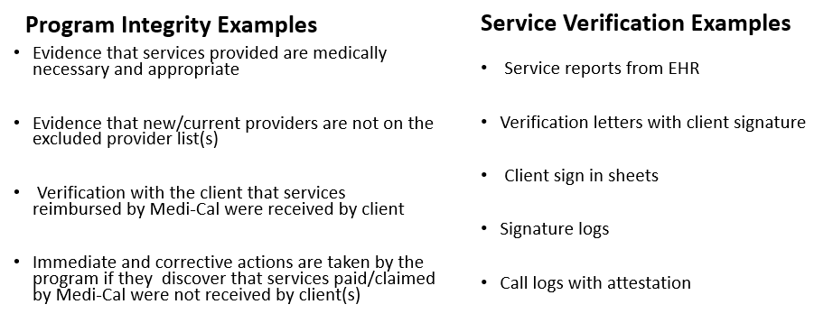
How to Complete: Speak with your COR about PI/PV outlined in your program’s Policies & Procedures (P&P’s).

Signature Logs

What It Is: A Signature Log is a list of all current staff providing direct services, their degree/licensure, job title, language capability (if applicable) and a copy of their typical signature. It is maintained at the program typically in a binder on paper.

Why Is It Required: All providers are required to maintain an accurate and current staff log signature. It is very important that the signature on the log be readily identifiable to the staff’s name as it appears on paper documents as well as in the EHR. For example, if a staff member goes by “Nick” but his name in the EHR is “Nicholas” please record this in the signature log. It is the organizational provider’s responsibility to update and maintain the log in a timely manner to reflect any changes, i.e., licensure, degree, job title, name, or signature.

How to Complete: OPOH Section G for more information.

Incident Reporting

What It Is: A reportable incident is an incident that may indicate potential risk/exposure for the County operated or contracted providers, member, or community.
- There are two (2) primary types of Incidents – Critical and Non-Critical
- Timelines: All providers are required to report \ incidents involving active members or whose discharge from services has been thirty (30) days or less within twenty- four (24) hours of knowledge of the incident.
- Critical Incident Categories:
  - Death/Pending (Pending CME investigation)
  - Suicide Attempt
  - Critical Injury on site (MH/SUD related)
  - Death/Natural Causes (Confirmed)
  - Death/Overdose (Confirmed)
  - Non-Fatal Overdose
  - Medication Error
  - Death/Homicide (Confirmed)
  - Death/Suicide (Confirmed)
  - Alleged abuse/inappropriate behavior by staff
  - Injurious assault by a client resulting in hospitalization
  - Adverse Media/Social Media Incident (only; no leading incident)

- Non- Critical Incident Categories

  - AWOL
  - Contract/Policy violations by staff
  - Loss / theft of medication from the Facility
  - Physical Restraints
  - Tarasoff Reporting
  - Adverse Police/PERT Involvement onsite
  - Medication Error
  - Non-critical injury onsite
  - Property destruction onsite
  - Other

Why It Is Required: When an Incident occurs or are identified, the appropriate agencies must also be notified within their specified timeline and format (i.e. police, child/elder abuse hotlines, other law enforcement, fire department, etc. It is also required that the program look into any incidents that happen on site and/or follow up with members who have exhibited dangerous behaviors via referral to appropriate resources / emergency sources as needed.
How to Complete: All information for Incident Reporting: webinar trainings, submission forms, tip sheets and further resources are located on the Optum Website> Incident Reporting tab and OPOH Section G.

- Critical Incidents are reported using the CIR Form located on the Optum Website > Incident Reporting tab
- N-CIRs are reported directly to your COR/Program Manager and to QA via an online submission form located on the Optum Website with NO identifying Protected Health Information (PHI).
- Please reference the tip sheets and webinars posted on Optum for step-by step instructions on how to fill out each document.

Timely Access Data Standards (TADT)
SmartCare: MH Non-Psychiatric SMHS Timeliness Record

What It Is: Access time refers to how long a member must wait to get a service at your program from the date the service was requested. For example, in an outpatient clinic with a limited number of staff, members may not be able to get an appointment with a therapist immediately. For the clubhouse, this is less of an issue as there are no “appointments” and it is very unlikely a client would ever have to wait to participate.

The standard is the following for non-psychiatric appointments:

Non-urgent with nonphysician MH care provider (routine) – within ten (10) business days from request

Example: This means that if someone calls and says “I want to become a member at your clubhouse” you have the room to say “sure, come in and become a member” with access to the clubhouse within the next ten (10) business days.

Why Is It Required: Long wait times for services can prevent members in the County from getting the help they need. The State requires the TADT to make sure people are connected to care as quickly as possible or referred to another clinic with more availability instead of being left in limbo.

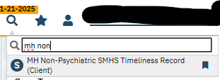
How To Complete:

- Look up the member in SmartCare

- Search for “MH Non-Psychiatric SMHS Timeliness Record”

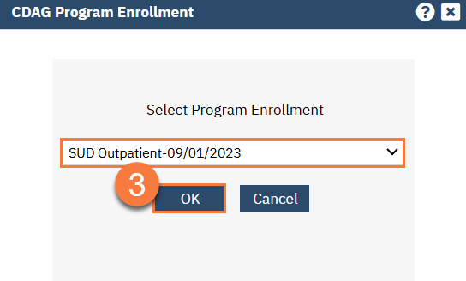
- Choose your program from the CDAG Enrollment Screen

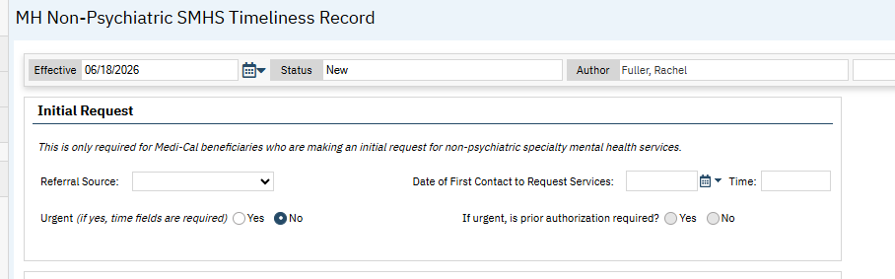
- Fill out the first section using the guidance below:

- Referral source

- Date of first contact to request services- the date and time you received the call from the member or the member walked in to request services

- Clubhouse referrals will not be Urgent (no for both radio buttons)

- Fill out the second section using the guidance below:

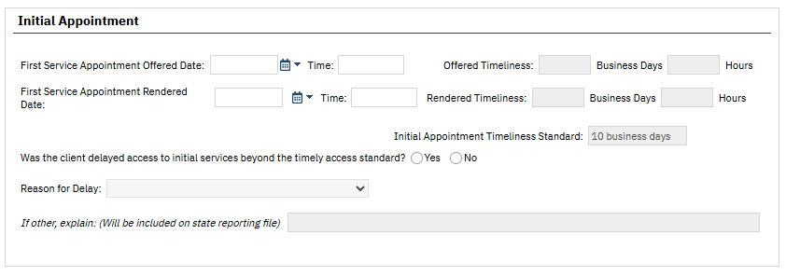

- First Service Appointment offered date: This is the first time/day staff has available to see the member and complete intake paperwork/introduce them to the clubhouse.

- For example, If a clubhouse’s hours are Monday- Friday 9am-5pm and staff are free any time to do an introduction/paperwork, then the “first service date/time” that day (i.e. June 18th at 9:00am).

- For example: A client calls at the very end of the day and wants to join the clubhouse. There may not be enough time for them to come in that day. In this case, the first service appointment date would be the next day (i.e. June 19th at 9:00am).

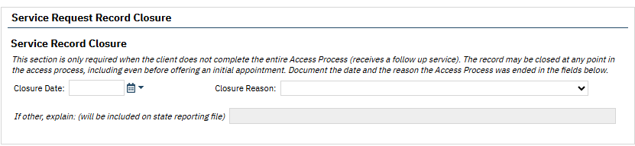
Bottom line: if from the time the member calls to request services is less than ten (10) business days from the first available appointment everything is within timelines.
- First Service Appointment Rendered Date: this is the date the member actually shows up for services. It can be filled out later if the first service appointment date and appointment rendered date are not the same.

- If members are working the front desk and taking phone calls it may be helpful to have them fill out something like the following on paper for new member inquiries. It can be entered into the TADT in SmartCare by a staff later.

- Reason for Delay: There should not be any reason for delay for access

Example New Member Form
Name of Caller:
Phone Number:
Intro meeting scheduled:
Intro meeting actual:

- The Follow Up Appointment section should not be completed. Select “N/A” radio button.
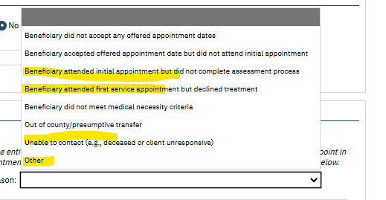
- Select “No” for Out of Network Referral section

- Service Request Record Closure

- This section should be completed for people who call and want to become a member but never come in. These should be closed at program discretion (i.e. at the end of each month, once per quarter, etc) with the appropriate reason for closure selected. The most likely reasons for closure have been highlighted in yellow in the picture above.

NOABD Logs

What It Is: NOABDs (Notices of Adverse Benefit Determination) are formal notifications required to be sent to members by providers which inform members of the health plan’s adverse decision, determination reasons and criteria when requested health benefits, coverage, or services are denied, reduced, or terminated. NOABDs also explain their rights to appeal the decision.

Why It Is Required: An NOABD is required to ensure Medi-Cal members receive timely, standardized, and legally compliant written notice when a decision is made that negatively affects their access to or payment for services.

How to Complete: There are eight (8) different kinds of notices all located on the Optum Website “NOABD” tab and outlined on the NOABD Tip Sheet found on Optum.

At the Clubhouse, you will likely use the following NOABDs:

- Delivery System Notice- It is issued when Clubhouse determines has determined that the member does not meet the criteria to be eligible for services (i.e. the member does not have a Serious Mental Illness) and makes a referral to a more appropriate system of care.

- The Timely Access Notice- When requested services (i.e. enrollment into the Clubhouse) cannot be provided within timelines ten (10) business days from date of request).

Client Programs Enrollment & Discharge
SmartCare: Client Programs (Client)
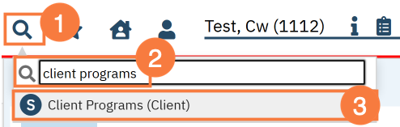
- Search for “Client Programs” under the client’s file in SmartCare

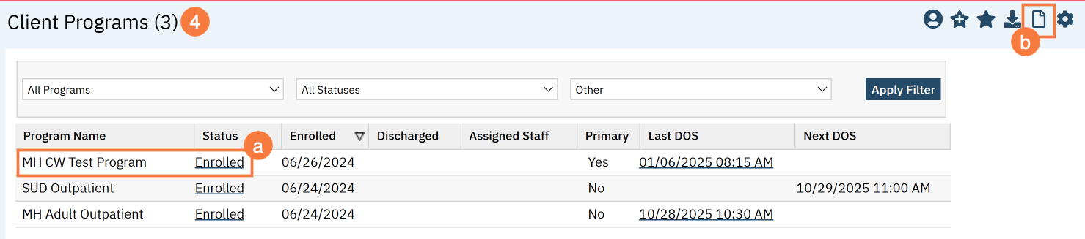
- Select the clubhouse (a) or add the clubhouse with the “new” icon (b)

- Change member status to “enrolled” or “discharged”

- Select your program from the dropdown menu.

- Enter the status “enrolled” or “discharged”

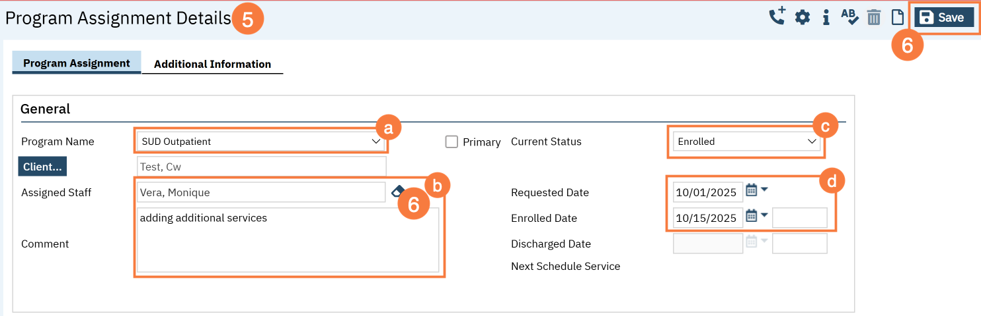
- Enter the enrollment / discharge date. This will be today’s date. You may leave the requested date blank, if it is not already entered.

Discharge

What It Is: A member has decided they no longer wish to participate in the Clubhouse, has been out of contact for an extended period despite outreach efforts, or has requested to close their membership for another reason (such as moving or connecting with a different program).

Why It Is Required: When a member leaves the Clubhouse, we want to ensure the transition is thoughtful and supportive. If the member is connecting with other services or community supports, this is an opportunity to help make that transition as smooth as possible. Completing the discharge process also fulfills State documentation and reporting requirements.

How to Complete: Whenever possible, have a conversation with the member about their transition. Discuss any ongoing supports that may be helpful, including community resources, crisis contacts if appropriate, medications (when applicable), and any follow-up services they plan to access. Document the member's reason for discontinuing clubhouse participation at this time, any transition planning that occurred, and complete the required SmartCare steps to close the member's enrollment in SmartCare.

A member being discharged from SmartCare is not meant to be a final closure of the relationship. Members should leave knowing they are valued and that the Clubhouse remains a welcoming community should they choose to return in the future.

Intake/ “Welcome” Packet

- Advance Directive- Required to be provided to the client at the first face-to-face with the client or upon turning eighteen years old (18) and documented in the client’s record and whether the client has an existing Advance Directive.

- Voter Registration- The voter registration is required to be offered at intake and documented.

- Language/Interpretation services and availability

- Problem Resolution (Grievance & Appeal) process and brochure- Grievance/appeal process information and State Fair Hearing is required to be provided to new members upon first admission and annually and must be documented as explained/given to member.

- BHP Notice of Privacy Practice

- Provider List- Programs can choose to provide the entire list or instructions for how to locate the list online

- Guide to Medi-Cal Healthcare services brochure is required to be provided when new members first obtain services – this should be monitored via Attestation vs every three (3) years at recert.

Please see the Optum website> Beneficiary tab for further information and for printable copies of required documents.

CSI Standalone Collection
SmartCare: CSI Standalone Collection

What Is It: A Client Services Information (CSI) record must be completed in SmartCare for:
- Admission
- Annually
- Discharge

Why is it Required: This is a State requirement for demographic information.

How to Complete: It should be filled out with as much information as possible. Although there is a downtime form for this document it MUST be entered electronically into SmartCare so the data can be provided to the State.

ASCMI
SmartCare: ASCMI (Non-AB 133 form)

What Is It: The ASCMI Form is a standardized consent to share information form that
providers will use to obtain an individual’s consent to share certain sensitive
physical health, behavioral health, housing, and social services information
across providers outside of the electronic health record. The ASCMI Form is a release of information form you can use to request your member’s consent to share their information with providers that are also a part of their care team. The form is meant to improve care coordination across multiple providers

Please note- only one of these documents is required per member in SmartCare. If the member already has an ASCMI form in SmartCare it does not need to be re-completed. The ASCMI form needs to be updated annually.

Why is it Required: The ASCMI is required to be offered to every member. If it is completed on paper it must be entered electronically into SmartCare. Even if members decline to sign the form, it still must be completed and their option to decline can be marked on the form.

How to Complete: How to Complete the ASCMI - 2023 CalMHSA

- Although there is a downtime form for this document it MUST be entered electronically into SmartCare so the data can be provided to the State.

Consents
SmartCare: Consent to Treat (Client), Consent for Telehealth (Client), Consent for Text Communication (Client), Consent for Email communication (Client)

What Are They: A consent is the formal agreement that a member voluntarily authorizes staff to offer and deliver specific mental health treatments or provide information to them via certain forms of communication. The member has been given sufficient information about the proposed treatment, including its purpose, expected benefits, risks, alternatives, and what might happen without treatment. Additionally, consent for telehealth in mental health requires that members are fully aware of what to expect during a remote session and privacy measures, such as using headphones, and understanding that electronic communications carry some risk of interception or unauthorized access.

Why Are They Required: Consents are required in Specialty Mental Health Services (SMHS) to ensure that members are fully informed, voluntarily agree, and understand the nature of the services they are receiving. The ASCMI and the Consent to Treat are the only specific consent form that is required- programs may use their own consents as long as they have all required elements and are uploaded into SmartCare.

How to Complete: Consents (Client) List Page - 2023 CalMHSA

Special Population Tracking
SmartCare: Special Populations (Client)

What It Is: A “flag” on member’s charts to identify if are part of a “special population” such as probation, LPS Conservatorship, homelessness, etc.

Why It Is Required: Tracking of homelessness is required for all BHS funded programs for data tracking purposes.

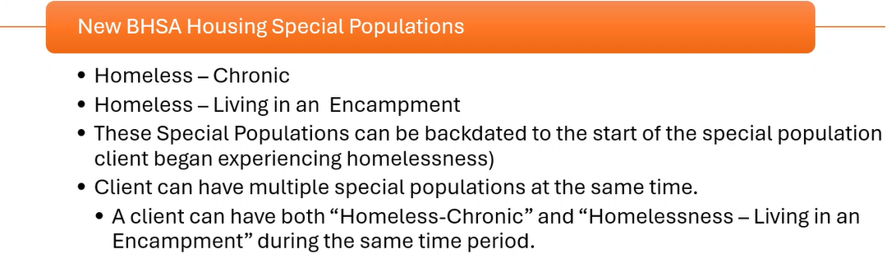
Homeless members must have this added as a special population using the best fit description of one of the following below:

Please note: If the member does not know the exact date they became homeless, staff can use their best estimate.

How to Complete: How To Identify a Client as Katie-A or Other Special Population - 2023 CalMHSA

Mental Health Assessment
SmartCare: Mental Health Assessment

What It Is: The mental health assessment is not meant to feel like a clinical interview. Instead, think of it as a "getting to know you" conversation that helps us learn about each member's story, strengths, goals, and the ways the Clubhouse can support their recovery. The information gathered helps us understand what is important to the member and ensures they receive the services that best meet their needs.

Why It Is Required: Every Clubhouse member receiving Specialty Mental Health Services (SMHS) must have an assessment.

- The assessment helps:
- Understand the member's goals and needs
- Identify how mental health impacts daily life
- Support a behavioral health diagnosis
- Demonstrate medical necessity for Medi-Cal services
- Develop an individualized treatment plan

Licensed vs. Non-Licensed Staff members

- Non-licensed staff can gather much of the assessment information through conversations with members.

- Licensed staff must co-sign the assessment and complete the clinical portions of, including:

  - Mental Status Examination (MSE) – Domain 1
  - Clinical Summary- Domain 7
  - Diagnosis - Domain 7
  - Medical Necessity- Domain 7
  - Level of Care- Domain 7

Licensed providers may use information gathered by non-licensed staff, documenting:
"Information obtained by [Provider Name, Credential]."

How to Complete: *Please see Appendix Section for sample Mental Health Assessment & Cheat Sheet

Making the Assessment Feel Like a Conversation

You might say to a new member: “This is just a conversation so we can figure out how the Clubhouse can support you. You can skip any question you'd rather not answer today." There is no requirement to complete the entire assessment in one sitting.
Many Clubhouses find it easier to complete the assessment over 2–3 visits, allowing time to build trust and get to know the member naturally.

For example:

Visit 1 – Getting to Know the Member
- Build rapport
- Learn about interests and strengths
- Discuss why they came to the Clubhouse
- Identify hopes and goals

Visit 2 – Daily Life and Recovery
- Learn about routines
- Discuss work, school, housing, relationships, and wellness
- Explore challenges and supports

Visit 3 – Complete Remaining Information
- Review anything still needed
- Licensed staff complete the clinical portions of the assessment + Mental Status Exam (MSE)

If the Member Already Has an Assessment:

If the member recently completed an assessment with another behavioral health provider, clubhouse staff may:

- Review the previous assessment.

- Gather information to complete Sections 1 and 7 specific to the clubhouse

- Information from sections 2-6 may be pulled forward (via copy/paste) into the Clubhouse assessment.

  - At the top of each section 2-6 include the statement: "The following information was reviewed and accepted from a previous assessment dated [date] and completed by [previous program]”.

- A licensed clinical staff member will need to co-sign the assessment for completing the clinical sections.

When Should Assessments Be Updated?

Update the assessment whenever there is a significant change in the member's life, such as:

- Psychiatric hospitalization
- Housing changes
- Employment changes
- Significant increase or decrease in symptoms
- Major life events
- New recovery goals

All seven (7) domains are required to be completed in the assessment. They are outlined below with some examples questions that may help gather necessary information.

Domain 1: Presenting Problem

Learn about what is happening in the member's life and what they hope to accomplish.

Please note this section should include a Mental Status Exam that must be completed by a licensed clinical staff member.

Example questions:

- Tell me about yourself.

- What brought you here?

- What are you hoping to get out of the Clubhouse?

- What has been making life harder lately?

- What would you like more of in your life?

- If things were going really well six months from now, what would your life look like?

Members may describe:
- Feeling lonely
- Anxiety around other people
- Low motivation
- Trouble keeping a job
- Feeling isolated
- Wanting friendships

Remember to connect these concerns to how they affect the person's daily life and mental health.

- Examples:
  - Feeling lonely- a member with depression may have low self-esteem which prevents him from wanting to make friends

  - Anxiety around people – a member with schizophrenia may feel anxious around other people due to hearing voices

  - Trouble getting out of bed- a member with depression may have trouble getting out of bed due to poor sleep quality

  - Losing motivation- a member with depression may lack the motivation to leave their home, shop for groceries or take care of their daily needs (i.e. bathing, brushing teeth, etc).

  - Not working anymore- a member with bipolar disorder may have quit their job impulsively during a recent manic episode

  - Feeling isolated- a member with depression may feel as though she is the only person in the world feeling this way.

  - Wanting friends- a member with social anxiety may feel too overwhelmed to leave their home to make friends.

Domain 2: Trauma

- Only ask enough to understand whether trauma has affected the member's recovery. Members do not need to share details if they are uncomfortable. This can also be asked by the licensed staff member.

  - Example question: Have you ever experienced anything deeply troubling or upsetting in your life that you think may have affected your goals, relationships or symptoms?

Domain 3: Behavioral Health History/Co-occurring Substance Use

Learn about previous behavioral health treatment and substance use.

Example questions:

- Have you received mental health services/ sought help with [stressor] before?

- Have you ever been hospitalized?

- Is there anything you've found helpful in the past?

- Have alcohol or drugs ever been a concern for you?

Domain 4: Medical History/ Current Medications / Co-Occurring Disorders

Learn about current physical health and medications.

Example questions:

- Are you taking any medications?

- Do you have any medical conditions?

- Do you have a primary care doctor?

Domain 5: Social and Life Circumstances/ Culture/ Religion/ Spirituality

Learn about the member's life outside the Clubhouse.

Example questions:

- What does a typical day look like?

- Have you worked before?

- Would you like to work again?

- Are you interested in school?

- Who do you spend time with?

- Is religion or spirituality important to you?

Domain 6: Strengths, Risk Behaviors and Protective Factors

Strengths: What is going well.

Example Questions:

- What are you really good at?

- What are you proud of?

- What helps you through difficult days?

- Who supports you?

- What kinds of work or hobbies do you enjoy?

Risk Behaviors: Explain- "I ask everyone these questions because we want to make sure everyone is safe."

- Have things ever felt so overwhelming that you wished you weren't here?

- Have you had thoughts of hurting yourself or others?

- Do you feel safe today?/ Have you ever felt unsafe?

Domain 7: Clinical Formulation & Diagnosis

Please note this section must be completed by a licensed clinical staff member.

The licensed clinician will complete:
- Clinical Summary
- Diagnostic Impression
- Medical Necessity
- Level of Care
- Clinical Recommendations

Diagnosis Document
SmartCare: Diagnosis Document

What It Is: Each program must have a program-specific Diagnosis Document that matches the symptoms and member presentation described in the notes and the most recent assessment.

Why It Is Required: This is required in order to bill for services.

How to Complete:

- The actual diagnosis and justification for the diagnosis must be completed by a licensed/waivered clinician or a clinical trainee with co-signature/registered clinician. - CALMHSA Documentation Guide- Appendix III (pg. 39)

- IF a licensed clinician cannot meet with the member for the first session, a Z code can be given to the member in order to temporarily bill.

  - Z codes may be used temporarily as a primary diagnoses during the assessment phase of Specialty Mental Health Services (SMHS) when a formal mental health diagnosis has not yet been established, provided documentation supports medical necessity.

  - Some common Z codes might be:

    - Z93.89 Encounters where a patient is evaluated for a suspected disease or condition, but after examination and testing, the condition is ruled out
    - Z59.0 Homelessness
    - Z59.5 Extreme poverty
    - Z56.0 Unemployment, unspecified

  - Complete list of Z codes: V Codes (DSM-5) & Z Codes (ICD-10) - PsychDB

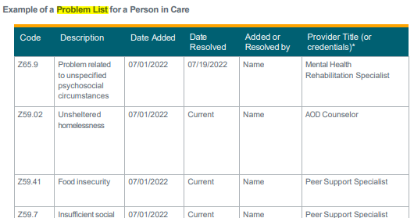
Problem List
SmartCare: Client Clinical Problem Details

What It Is: A problem list is a list of a member’s symptoms, conditions, diagnoses, and risk factors. A Problem list is required for all members.

Why It Is Required: It serves as an organized snapshot of a member’s treatment needs and is essential for coordinated care.

How to Complete: How to Add a Problem to the Problem List - 2023 CalMHSA & How to Remove a Problem from the Problem List- 2023 CalMHSA

- Updates to problem lists: Staff should update the problem list when a member reports a new issue in their life or observation of additional/ resolved issues.

- There is only one (1) problem list needed per member. This means that multiple providers may be adding to the same problem list.

  - Before you add a new problem to the problem list, please review the current problems to make sure it is not already on the list. If it is, there is no need to add it again.

  - If a member is open to another provider and has a Problem List already, the new clubhouse should review the current Problem List with the member and document that the list was reviewed with the member and accepted/ or changed.

- Please note that the problem list may include the diagnosis, but it is not required

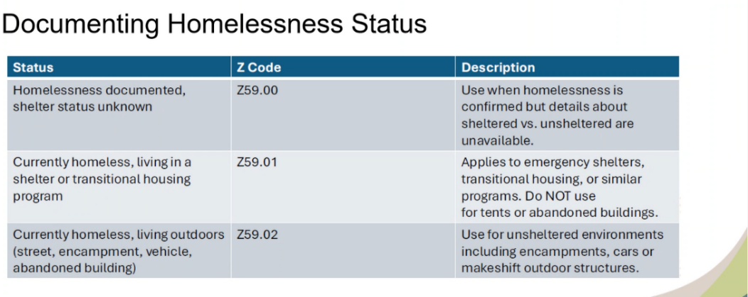
- It is required for all BHS funded programs that if a member is homeless it is on the Problem List by one of the following Z codes:

Service Note
SmartCare: ISL Client Non Billable Srvc Must Document

What It Is: All members must have at minimum one (1) progress note per day. Notes must be signed in order to be valid.

Why It Is Required: Notes are used to document the treatment that has occurred and may serve as communication tools to alert other providers of the status of treatment. Each progress note shall provide sufficient detail to support the service code(s) selected for the service type(s).

How to Complete: How to Write a Progress Note for a Scheduled Service - 2023 CalMHSA

Please note: Any staff can complete a note (i.e. MHRS, Other Qualified Professional, etc), however, if the note indicates any safety issues it must be co-signed by a licensed/waivered/registered staff.

Timeframe: Providers shall complete progress notes within three (3) business days of providing a service, with the exception of notes for crisis services, which shall be completed within one (1) calendar day. The day of the service shall be considered day zero (0).

Staff will enter all service notes as non-billable notes (ISL Client Non Billable Srvc Must Document) in SmartCare.It is very important that the member time in and time out of the clubhouse is documented in order to justify the three (3) hour requirement for billing. Billing staff will enter the bundled rate via an administrative entry process: Admin Entry Guide

Two Options- staff may either:

- Enter a non-billable service note into SmartCare by copying and pasting the Clubhouse Note Template OR

- Completing the Clubhouse Note Template on paper and scanning it into SmartCare

Members who do not stay for three (3) hours:

If members do not stay for the required 3 hours for billing a full service note does not have to be completed. providers may open a blank “non-billable” note without copying and pasting the template. This will leave an open block for text where the service and/or relevant information may be added. Please continue to note the “time in” and “time out” of the interaction with the member.

Note requirements: (BHIN 23-068)

- The type of service

- The date that the service was provided to the member

- Duration of direct patient care for the service.

- Location or place of service

- A typed or legibly printed name, signature of the service provider, and date of signature.

- A brief description of the service provided and how the service addressed the member’s behavioral health needs (e.g., symptom, condition, diagnosis, and/or risk factors).

- A brief summary of next steps

- In all documentation, it is beneficial to include direct quotes from the member.

- The correct service type must be billed (i.e. bundled rate vs. outpatient codes)

- In the notes you should “make the connection” for the reader. For example, we know that attending a social activity is beneficial because it helps people feel connected to one another, forms supportive relationships and prevents feelings of loneliness. Pretend the reader is from another planet and doesn’t know any of that.

  - For example, you might say “Joe attended a social activity today. This was helpful for Joe because one of his goals is to “make new friends” and this activity was a great way for Joe to connect to other members”

Goals & Next Steps

- Goals: Member’s goals should be identified somewhere within the medical record. This may include: the assessment, care planning section of the note, next step section of the note

- Next Steps: Since the member is likely attending the Clubhouse on a daily basis (as opposed to a weekly therapy appointment) the next steps should encourage participation, skill development, and community integration. It is important to note that these are short-term goals for next time they attend the Clubhouse, meaning they should be changing almost daily.

- Instead of writing: "Member will attend Clubhouse tomorrow”:

- "Member will meet with staff to identify the next step toward education, goals."

- “Member will practice one coping skill to reduce anxiety.”

- “Member will take on a new responsibility during the work-ordered day.”

- “Member will attend the next member meeting.”

- “Member will participate in a group lunch or social activity.”

- “Member will initiate conversation with at least one peer”.

- “Member will complete one job application.

Goals | Next Steps
Long-term outcomes the member wants to achieve  Where you want to end up | Short-term actions the member will take before the next visit or the next weeks  How you get there.
Part of the assessment and treatment plan | Documented in each service note
May remain the same for months | Change frequently based on progress
Example:  Goal: Obtain part-time employment within the next year.  Next Steps:  - Complete a resume with staff support.  - Apply for two jobs this week. | Example:  Goal: Increase meaningful social connections and reduce isolation.  Next Steps:  - Participate in the gardening unit.  - Attend Friday's social event.  - Introduce self to one new member.

Care Coordination
(CalMHSA Doc Guide- pg. 25)

- Clubhouses can determine whether the member is open to other programs via SmartCare Client Programs (Client)

- If a member has a primary treatment program, it can be helpful for the Clubhouse to have a release of information to communicate with the program- this would be documented via a separate non-billable note.

- Program should ensure that appropriate consents and Releases of Information (ROIs) are completed to communicate with the member’s clinical team/ support system if needed.

Member Safety

The Clubhouse is committed to providing a safe, welcoming, and supportive community for all members. While the Clubhouse is not a crisis or emergency mental health service, staff play an important role in recognizing when a member may need additional support and helping them connect to appropriate resources.
If a member expresses that they feel unsafe, is talking about harming themselves or others, or appears to be experiencing a mental health crisis:
- Stay with the member whenever possible and remain calm,

- Listen without trying to solve the crisis. Allow the member to share what they are experiencing and acknowledge their feelings.

- Notify a supervisor or designated Clubhouse leader immediately.

- Assess the level of urgency. If there is an immediate threat to the member's safety or the safety of others, call 911.

- Document the interaction and any actions taken according to Clubhouse and County documentation requirements.

Emergency Resources (County of San Diego)
- Immediate danger or medical emergency: Call 911.
- County of San Diego Access & Crisis Line (24/7): 888-724-7240 (7-1-1 TTY)
- 988 Suicide & Crisis Lifeline: Call or text 988 for immediate emotional support and suicide prevention assistance.
- Psychiatric Emergency Response Team (PERT)
  - Referrals to PERT are made through the 911 dispatch operator.

  - Provides emergency assessment and referral for individuals in behavioral health crisis. Pairs licensed mental health clinicians with uniformed law enforcement officers/deputies.

- Mobile Crisis Response Team (MCRT) - MCRT Fact Sheet
  - MCRT is deployed through calls made to the San Diego Access and Crisis Line (ACL) (888-724-7240) or emergency services. Trained dispatchers will assess the situation for risk and safety through a series of questions and will determine if MCRT or another crisis intervention or response service should be sent out.
  - Please note that MCRT can respond to behavioral health crisis calls that do not involve medical emergencies, weapons, or known threats of violence.
If the situation is urgent but not life-threatening the following resources can be utilized:
- Access & Crisis Line: 888-724-7240 (7-1-1 TTY) : Assist the member in connecting with the County of San Diego Access & Crisis Line (ACL), which is available twenty- four (24) hours a day, seven (7) days a week. The ACL provides crisis intervention, behavioral health referrals, and can dispatch the Mobile Crisis Response Team when appropriate.
- Clinical provider: If the member is connected to other treatment providers (i.e. outpatient clinic, therapist, etc), encourage the member to contact their mental health provider, psychiatrist, therapist, or other trusted support person if appropriate.
- Safety Plan - A Safety Plan may be completed if the staff feel it is beneficial to the member. A copy of Safety Plan should be offered to member and signed. Documentation Standards. Staff may choose to use the safety plan in SmartCare, the sample safety plan in the Appendix of this handbook or create their own. The safety plan should be kept in the member’s physical chart (if utilized) or uploaded into SmartCare.

Using the EHR (SmartCare)

SmartCare Training

Prior to staff obtaining access to SmartCare, they shall successfully complete all applicable SmartCare trainings. Program managers are responsible for registering new and returning SmartCare users for training on the CalMHSA LMS application. Previous users returning to employment (including maternity leave) after more than ninety (90) days of absence will be required to resubmit new paperwork including an updated ARF and be evaluated for a skills assessment or retraining.
Users are required to attend and pass the assigned online LMS trainings with CalMHSA prior to access. Staff will be responsible for trainings according to their Staff Role. The CalMHSA Required Trainings by Role Grid can be found on the Optum Website under the SOC Resources and Training. See the following grid for guidelines : SmartCare Trainings by Staff Role. For additional resources, please see: SmartCare User Training Registration and SmartCare Training Tips

Roles in SmartCare

Staff should be registered on the Access Request Form (ARF) as Mental Health Rehab Specialists (MHRS), Para-Pro/ Other Qualified Professional (OQP) or LPHA depending on their qualifications. While many Clubhouse staff may be certified PSS, the procedure codes that can be utilized by PSS are determined by DHCS guidelines and do not include the procedure code for the bundled day rate of Clubhouse Services.

Please see OPOH Section I for Staff Qualifications and descriptions:
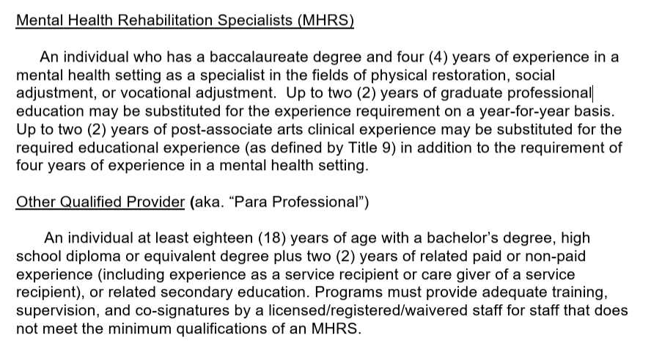
Please select your role, program managers must also select a category of MHRS, Para-Pro or other applicable category if they will be completing notes in the record. Do not list Certified Peer Specialist as a Clubhouse staff member.
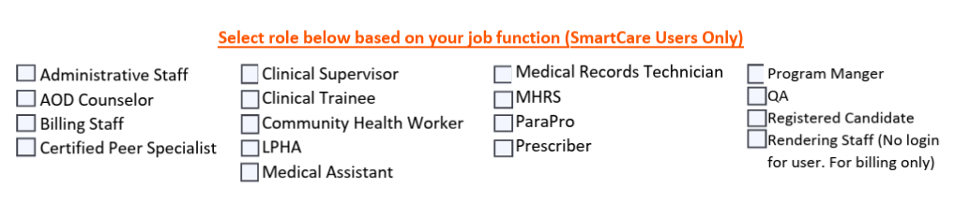
Additional Information:

NPI: All staff rendering Medi-Cal billable services must have their own NPI, this is separate from the program NPI. The NPI is issued through NPPES (National Plan & Provider Enumeration System. Application Link: https://nppes.cms.hhs.gov

Resources for Choosing Taxonomies

- How To Change Taxonomies
- Locating NPI and Taxonomy
- MH Guidelines for Choosing Taxonomies 03.21.25.pdf

SmartCare Workflow

Action | What is it Called in SmartCare | Staff | Resources/ Guidance
- Look up a new member to see if they are in the system yet. | Inquiries (My Office)  DO NOT USE DISPOSITION SECTION | Any staff with SmartCare access | Search by name, DOB, and SSN before you can create a new member in the system.  How to Document an Inquiry - 2023 CalMHSA
- Complete Timeliness Record (TADT) | MH Non-Psychiatric SMHS Timeliness Record | Any staff- If completed on paper, info must be entered into SmartCare in a timely manner | *NOABD to be completed if timeliness is unable to be met.  MH Access Times Tip Sheet  How to Document Timely Access Record Information for TADT - 2023 CalMHSA
- Enroll member to the clubhouse | Client Programs (Client) | Any staff with SmartCare access | How to Add the Client to Your Program - 2023 CalMHSA
- Complete consents | ASCMI (Non-AB 133 form) (if one has not yet been completed- only one needed per member. Must be updated annually)  Consent to Treat (Client)  Consent for Telehealth (Client)  Consent for Text Communication (Client) - (if applicable)  Consent for Email Communication (Client) - (if applicable) | Any staff- If completed on paper, info must be entered electronically (i.e. not scanned) SmartCare in a timely manner | Must use: ASCMI must be completed electronically in SC (even if member declines to sign).  All other consents are optional and should programs choose to use their own, they can scan copies into the system as  needed.  How to Complete the ASCMI - 2023 CalMHSA
- Complete required State forms | CSI Standalone Collection | Any staff with SmartCare access | How to Complete a CSI Demographic Record - 2023 CalMHSA
- IF APPLICABLE:  UMDAP  Client Plan Request Form | UMDAP Financial Assessment (Client) (if one has not been completed- only one per member. Updated annually)  Paper Document - (if one has not been completed- only one per member. Updated annually) | Any staff with SmartCare access | UMDAP Financial Assessment in SmartCare  How to Complete the SmartCare Client Plan Request Form  Optum Website> SmartCare Tab> Billing
- Complete assessment | Mental Status Exam (Client)  Mental Health Assessment (Client) | Information may be gathered by any staff but specific sections may only be completed in SmartCare by a licensed, waivered, registered staff: the MSE, diagnosis and clinical formulation | Mental Health Assessment - 2023 CalMHSA
- IF APPLICABLE: Identify special population | Special Populations (Client) | Any staff with SmartCare access | How To Identify a Client as Special Population - 2023 CalMHSA
- Establish diagnosis | Diagnosis Document (Client) | Only LPHAs have access in SmartCare | How to Document a Diagnosis - 2023 CalMHSA
- Establish problem list | Client Clinical Problem Details | Any staff with SmartCare access | * To complete if NOT done during the assessment phase or not being done when completing  the note.
- Write a note | ISL Client Non Billable Srvc Must Document | Any qualified staff. If the note indicates any safety issues it must be co-signed by a licensed/waivered/registered staff. | See “Clubhouse Handbook” > Service Note section  BHIN 23-068
- Discharge | CSI Standalone Collection (Client)  Client Programs (Client)  CalMHSA Discharge Summary (Optional) | Any staff with SmartCare access | ** NOABD may needed depending on reason for discharge.  How to Complete a CSI Demographic Record - 2023 CalMHSA  How to Close a Client to a Program - 2023 CalMHSA  How to Complete the Discharge Summary - 2023 CalMHSA

Billing Corrections

It is recommended that programs run the Service Error Report at least one (1) time per week to manage and correct any potential billing errors.

- Optum > SMH & DMC-ODS Health Plans >

  - SmartCare Tab> Workflows and Documentation> Clearing COSD Service Error Report (My Office)

  - Billing Tab> MH & DMC-ODS> Billing Unit Payment Recovery Form

- Service Note Errors and How to Resolve (CalMHSA)

- How to Report an Error (CalMHSA)

Resources

Accreditation
- Clubhouse International Accreditation

Communications & Trainings
- Behavioral Health Information Notices (BHINs) are communications sent out by the Department of Health Care Services. They typically reflect important changes to rules and regulations. The QA department will “translate” and communicate important information to the system of care through UTTM’s (monthly emails) and QIP meetings.

- BHS Email Communications- Program staff can subscribe to the GovDelivery platform to receive BHS communications that go out to the system of care such as meeting notifications (e.g. QIP, SmartCare User Group, etc.), Information Notices, UTTMs (Up to the Minute Monthly Newsletters), BHINs, OPOH Updates, Upcoming Trainings (e.g. Audit Leads, Progress Note Practicum), etc.

  - The BHS GovDelivery Flyer includes step by step instructions to subscribe

    - To receive these notices as well as other important meeting invites and communications: Specialty Mental Health Services & SmartCare

- Up to the Minute (UTTM) - QA publishes a monthly newsletter to inform providers of important changes to regulations and/or requirements. This is one of the main tools for providing information to the system of care.

Documentation
- BHIN 23-068
- CalMHSA Clinical Documentation-Guide-04.2026.pdf
- CalMHSA Scope of Practice Matrix Appendix III (p.39)

Important Contacts
- QI Matters: QIMatters.HHSA@sdcounty.ca.gov- Primary email for the QA department. Staff are available for questions and consultation regarding various documentation and quality assurance issues.

- SmartCare system issues (glitches, functionality, pop up errors): CalMHSA Help Desk

- Support for questions that CalMHSA Help Desk can’t address/resolve (i.e. program / system changes, corrections or deletions): BHS_EHRSupport.HHSA@sdcounty.ca.gov
- Billing issues / questions: MHBillingUnit.BHS@sdcounty.ca.gov

- Access issues/questions, SmartCare ARF submissions: BHS_EHRAccessRequest.HHSA@sdcounty.ca.gov

- Questions related to documentation, guidelines or policy: QIMatters.HHSA@sdcounty.ca.gov

- Questions or requests regarding reports: BHS-DataScience.HHSA@sdcounty.ca.gov

- Privacy Incident Reporting and other Privacy Resources : All privacy incidents are reported directly through the HHSA Compliance Office online portal - HHSA Compliance Office

Important Websites
- Optum San Diego Website- SMH & DMC-ODS Health Plans & CalAIM for BHS Providers
  - Optum San Diego Website- SMH & DMC-ODS Health Plans> MH Resources> Clubhouse Services

- CalMHSA Website: https://2023.calmhsa.org/

- Organizational Providers Operations Handbook (OPOH) - The OPOH is a document containing a broad source of information for all topics involved in managing a program within the County of San Diego.

  - The most current version is always found on the OPTUM San Diego Website > OPOH tab.

Policy
- SPA 24-002
- BHIN 25-009
- EBP Policy Guide- Rev. 5.1.25

Appendix

Clubhouse Assessment Cheat Sheet

Use these questions as a guide and allow the conversation to flow naturally. You do not need to ask every question or ask them in this order.

1. Get to Know the Member- Start with relationship building.
- Tell me a little about yourself.
- What brought you to the Clubhouse?
- What are you hoping to get out of being here?
- What would make coming here worthwhile for you

2. Learn About Their Daily Life
- What does a typical day look like?
- What do you enjoy doing?
- Who do you spend time with?
- What does a really good day look like?
- What does a difficult day look like?

3. Explore Challenges- Focus on how stressors/ symptoms affect everyday life.
- What has been making life harder lately?
- What gets in the way of doing the things you'd like to do?
- What would you like more of in your life?
- Is there anything you wish was different?

Listen for things like:
- Isolation
- Anxiety
- Depression
- Low motivation
- Difficulty working
- Trouble maintaining relationships
- Housing concerns
- Difficulty managing daily activities

4. Discover Their Strengths
- What are you really good at?
- What makes you proud?
- What kinds of work or hobbies do you enjoy?
- What helps you get through difficult days?
- Who supports you?

5. Goals- If everything went really well...
- What would your life look like?
- What would you be doing?
- What would you like to accomplish?

Examples:
✔ Make friends
✔ Get a job
✔ Return to school
✔ Leave the house more often
✔ Feel more confident
✔ Learn new skills
✔ Live more independently

6. Work, School & Community
- Have you worked before?
- What jobs have you enjoyed?
- Would you like to work again?
- Are you interested in school or training?
- What would you like to learn?

7. Health & Wellness
- Are you taking any medications?
- Do you have any health concerns?
- What helps when you're stressed?
- What makes things worse?

8. Trauma (Only ask if appropriate) The member does not have to share details.

"Have you experienced anything difficult that you feel still affects your life today?"

9. Safety - Normalize the conversation: "I ask everyone these questions because we want to make sure everyone is safe."

- Have things ever felt so overwhelming that you wished you weren't here?
- Have you had thoughts of hurting yourself?
- Do you feel safe today?

Sample Mental Health Assessment (New Member)

Start Date: _04/10/26 End Date: _04/10/26_Client: _Jane Doe_ ID#: 1234567_ DOB: 5/12/1993_

Domain 1: List/Describe Presenting Problem(s), Current Mental Status, History of Presenting Problem(s) and Client Identified Impairment(s).

Jane is a 33-year-old, English speaking, Hispanic female presenting as a new member today for Clubhouse services. She has been experiencing increased depression and anxiety over the past year after the death of her mother and losing her job. This has led to a decrease in motivation, spending more time alone, worrying about money and the ability to continue her usual routines. Jane stated: "I know I'm capable of doing these things, but it feels like my brain and body won't cooperate." Before experiencing these challenges, Jane enjoyed working, spending time with others, attending church activities, and being involved in her community.

Jane would like to join the Clubhouse for additional support having a routine in her day, meeting people and returning to her job when she feels ready.

Mental Status Exam (Completed by Licensed Clinician – Rachel Fuller, LPCC₎
Appearance: Clean, casually dressed, appropriate hygiene
Behavior: Cooperative and engaged
Speech: Normal rate and volume
Mood: "Depressed and anxious"
Affect: Restricted but appropriate
Thought Process: Logical and goal directed
Thought Content: No delusions or hallucinations reported
Orientation: Alert and oriented ×4
Memory: Intact
Insight: Good
Judgment: Fair
Attention/Concentration: Mildly impaired by anxiety

Domain 2: List/Describe Trauma - Indicate N/A if not applicable.

Jane grew up in a home where her parents frequently fought. She shared that seeing this was very stressful for her and made her feel responsible for protecting her siblings. Jane believes this still affects her today as she has increased anxiety when she experiences conflict or feels criticized. Jane was previously in a relationship where she experienced emotional abuse. She now says she has “bad self-esteem” and difficulty trusting others.

Domain 3: List/Describe Behavioral Health History and Comorbidity.

Jane has received support in the past for her described issues via counseling several years ago,. She found talking with someone helpful. Jane has never been hospitalized for mental health issues. She currently takes medications for her depression symptoms prescribed by her primary care doctor although she has recently had trouble remembering to take her medications regularly. Jane occasionally drinks alcohol occasionally in social situations and does not feel that substance use has negatively affected her life. She does not use any other substances.
Domain 4: List/Describe Medical History, Current Medications, Medication History, and Comorbidity with Behavioral Health.

Jane sees her primary care doctor for hypothyroidism and occasional migraines. She says that she “gets nervous about getting a migraine” and this has a negative impact on her day. Jane says when she has a migraine she feels “more depressed” and has difficulty sleeping, “doesn’t want to do anything” and typically does not get out of bed which makes her feel more anxious.

Domain 5: List/Describe Social and Life Circumstances and Culture/Religion/Spirituality.

Jane lives in a one-bedroom apartment. She is very concerned about paying her rent after losing her job. Jane is close with her older sister who gives her rides when Jane does not have money for gasoline. Jane likes to hang out with some friends in her building but says she has been “avoiding them” due to “not feeling like herself”.
Jane identifies as Hispanic and says that her parents had “traditional” roles- meaning her father worked and her mother “stayed home and raised us”. Jane and her siblings were supposed to “be quiet when dad was home”. Spirituality has always been an important aspect of her life. She used to attend church before she started feeling worse. She says she misses church.

Domain 6: List/Describe Strengths, Risk Behaviors, and Safety Factors.

Jane’s says that she is “a good listener” and “a good friend”. She feels best when she is “attending church” and “talking with her sister”. Staff also observed additional strengths such as: reaching out for help, current housing and motivated to return to work. Jane identified goals including: returning to work, rebuilding relationships and becoming more active in her community. Jane says she has never made an attempt to harm herself or others. She does state: “when my depression is bad "I sometimes I wonder if people would be better off without me." Jane says that she will not harm herself due to her religion (“suicide is a sin”) , her sister (“I can’t do that to her”) and her friends.

Domain 7: List/Describe Clinical Summary and Recommendations, Diagnostic Impression, and Medical Necessity Determination/Level of Care/Access Criteria.

Completed by licensed clinician Rachel Fuller, LPCC
Jane is a member seeking support after experiencing increased depression and anxiety that have affected several important areas of her life, including employment (i.e job loss), social relationships (i.e. increased isolation), daily routines (i.e. difficulty paying bills and keeping appointments), and participation in meaningful activities (i.e. low motivation to attend church). Her symptoms are consistent with Major Depressive Disorder, Recurrent, Moderate, and Generalized Anxiety Disorder: decreased motivation, isolation, difficulty completing responsibilities, and reduced involvement in activities that previously provided purpose and connection. These symptoms have resulted in clinically significant impairment across multiple life domains, including employment, activities of daily living, interpersonal relationships, and emotional functioning. She has demonstrated limited improvement despite support from family and pharmacological treatment initiated by her primary care physician.

Jane would benefit from Specialty Mental Health Services via the clubhouse focused on: participating in the work-ordered day , developing routines and structure , exploring employment interests , Building relationships with other members , reducing isolation, practicing daily living skills , increasing confidence and identifying personal goals

Problem List:
Description | ICD 10 Code | Start Date | End Date
Problems related to employment and unemployment | Z56.0 | 07/10/26
Problems related to housing and economic circumstances | Z59.0 | 07/10/26
Problems related to life management difficulty | Z73.0 | 07/10/26

Sample Mental Health Assessment (Assessment completed by another provider)

Start Date: 07/14/26_ End Date: 07/14/26_Client: Jane Doe ID#: 1234567 DOB: _5/12/1993

Domain 1: List/Describe Presenting Problem(s), Current Mental Status, History of Presenting Problem(s) and Client Identified Impairment(s).

Jane is a 33-year-old, English speaking, Hispanic female presenting as a new member today for Clubhouse services. She has been experiencing increased depression and anxiety over the past year after the death of her mother and losing her job. This has led to a decrease in motivation, spending more time alone, worrying about money and the ability to continue her usual routines. Jane stated: "I know I'm capable of doing these things, but it feels like my brain and body won't cooperate." Before experiencing these challenges, Jane enjoyed working, spending time with others, attending church activities, and being involved in her community.

Jane would like to join the Clubhouse for additional support having a routine in her day, meeting people and returning to her job when she feels ready.

Mental Status Exam (Completed by licensed clinician Rachel Fuller, LPCC)
Appearance: Clean, casually dressed, slightly disheveled, appropriate hygiene
Behavior: Cooperative and engaged
Speech: Normal rate and volume
Mood: "Depressed and very anxious"
Affect: Restricted but appropriate
Thought Process: Logical and goal directed
Thought Content: No delusions or hallucinations reported
Orientation: Alert and oriented ×4
Memory: Intact
Insight: Good
Judgment: Fair
Attention/Concentration: Member is easily distracted.

Please note that historical information below has been reviewed and accepted from a previous assessment completed on 04/10/2026 by New Life Outpatient Services.

Symptoms worsened following the death of her mother (2025) and job loss due to poor attendance, sleep issues, anxiety and difficulty getting out of bed. In April, Jane reported: increased financial stress, greater social isolation, and worsening feelings of hopelessness. She reported crying several times each week, spending much of the day in bed when she does not have appointments and avoiding social invitations because interacting with others feels overwhelming. She also reported excessive worry about finances, disappointing family members, and uncertainty about her future. She describes frequent self-critical thoughts and diminished confidence in her ability to manage daily responsibilities.
Domain 2: List/Describe Trauma - Indicate N/A if not applicable.

Previous information from assessment completed on 04/10/2026 by New Life Outpatient Services indicates the following:

As a child, Jane described witnessing domestic violence between her parents, describing her childhood as unpredictable and stressful. She has occasional intrusive memories when exposed to yelling or interpersonal conflict and increased anxiety when criticized or involved in conflict. History of emotionally abusive relationship which negatively affected her confidence and ability to trust others.

Domain 3: List/Describe Behavioral Health History and Comorbidity.

Historical information below has been reviewed and summarized from a previous assessment on 04/10/2026 by New Life Outpatient Services.

Jane first experienced symptoms of anxiety during adolescence and periods of depression in her early twenties. Symptoms improved with support from family and friends until the recent losses she experienced. Approximately six years ago she participated in outpatient psychotherapy for eight months following her divorce. Reports drinking alcohol socially but has no concerns about substance use.

Domain 4: List/Describe Medical History, Current Medications, Medication History, and Comorbidity with Behavioral Health.

Historical information below has been reviewed and summarized from a previous assessment on 04/10/2026 by New Life Outpatient Services. Jane has confirmed that this information is still accurate.

History of hypothyroidism and occasional migraine headaches managed by her PCP. Medications: Sertraline 100 mg daily , Levothyroxine daily and Sumatriptan as needed. As of July, her sleep is still poor with frequent waking. Appetite has improved slightly.

Domain 5: List/Describe Social and Life Circumstances and Culture/Religion/Spirituality.

Information below has been reviewed by staff and member and accepted as still accurate from assessment completed on 04/10/26 by OP program.

Jane continues to live in a one-bedroom apartment. In April she expressed concern regarding financial stability following job loss but has been able to maintain housing with assistance from savings and occasional financial support from her sister. Jane has a close relationship with her older sister. Jane identifies as Hispanic and stated that family, cultural traditions, and spirituality have always been important aspects of her life.

Domain 6: List/Describe Strengths, Risk Behaviors, and Safety Factors.
Information below has been reviewed by staff and member and accepted as still accurate from assessment completed on 04/10/26 by OP program.

Jane’s says that she is “a good listener” and “a good friend”. She feels best when she is “attending church” and “talking with her sister”. Staff also observed additional strengths such as: reaching out for help, current housing and motivated to return to work. Jane identified goals including: returning to work, rebuilding relationships and becoming more active in her community. Jane says she has never made an attempt to harm herself or others. She does state: “when my depression is bad "I sometimes I wonder if people would be better off without me." Jane says that she will not harm herself due to her religion (“suicide is a sin”) , her sister (“I can’t do that to her”) and her friends.

Domain 7: List/Describe Clinical Summary and Recommendations, Diagnostic Impression, and Medical Necessity Determination/Level of Care/Access Criteria.

This section completed by licensed clinician Rachel Fuller, LPCC.

Jane holds a diagnosis from 04/2026 of F33.1 Major Depressive Disorder, Recurrent, Moderate, and F41.1 Generalized Anxiety Disorder. This clinician has reviewed her current/continuing symptoms and has determined that these diagnosis are still accurate.

Jane continues to grieve the loss of her mother and is still unemployed which threatens her housing. Current symptoms continue to be a persistent depressed mood, diminished interest in activities, social withdrawal, sleep disturbance, fatigue, excessive worry, impaired concentration, decreased motivation, and feelings of hopelessness.
These symptoms have resulted in clinically significant impairment across multiple life domains, including employment, activities of daily living, interpersonal relationships, and emotional functioning. Jane is currently receiving medication support.

Jane continues to meet DHCS Specialty Mental Health Services criteria because she has covered mental health diagnoses that result in significant distress and impairment in major areas of functioning, including employment, independent living skills, social relationships, and emotional regulation. Participation in the Clubhouse will help bring routine and structure to her day as she is currently lacking motivation to get out of bed and participate in life due to symptoms of depression.

Jane has expressed wanting to get back to work and will be able to explore employment interests with staff at the clubhouse as well as develop time management and employment skills. Jane has been suffering from isolation which is increasing feelings of depression and anxiety, these symptoms will be mitigated by building relationships with other members. Other goals will continue to be developed as Jane continues participation in Clubhouse activities and experiences. Without clubhouse services, Jane risks worsening symptoms of depression and anxiety that may lead to loss of housing, severe financial stability, losing support from friends and family and eventual need for hospitalization to stabilize symptoms.

Clubhouse Service Note Template

Member: __________________________ID#: ___________DOB: _______________

Status: ☐ Show ☐ No Show ☐ Cancel Cancel Reason: _______________

Program: ________________________________ Date: ______________________

Procedure: _____________________________ Start Time: _________________

Location: _______________________________ End Time: _________________

Staff: __________________________________ Face to Face Time: __________

Mode of Delivery: _________________________ Documentation Time: _________

Interpreter Services Needed ☐ Yes ☐ No Language: _______________

Activities Completed (at least one must be present):
☐ Employment / Education Support
☐ Medication Support Services
☐ Psychosocial Rehabilitation
☐ Referral and Linkages
☐ Treatment Planning

Other Activities Completed:
☐ Unit Work Activity
☐ Social/Recreational Activity
☐Wellness Activity
☐ Community Integration
☐ Other: ______________________

Interventions/Support Provided- _________________________________________

______________________________________________________________________

Behavioral Health Need Addressed: _______________________________________

_____________________________________________________________________

Member Response
☐ Fully engaged
☐ Partially engaged
☐ Required prompting/redirection
☐ Declined participation

Member response to support and activities: ___________________________________

Progress Toward Goals- Activities supported the member’s goals related to:

☐ Independent living skills
☐ Social connectedness
☐ Community integration
☐ Education/employment
☐ Wellness and recovery management
☐ Other: _______________________

Observed progress: ______________________________________________________________________

______________________________________________________________________

Safety-The following safety issues were present:
☐ Danger to Self
☐ Danger to Others
☐ Other: ________________________
☐ No safety issues

Safety Issues: __________________________________________________________

Plan/ Next Steps: _______________________________________________________

Signature: ___________________________________ Date: ____________________

Printed Name: ___________________________________________________

Clubhouse Service Note Cheat Sheet

Member: Member Name ID#: Member SmartCare ID Number DOB: Date of Birth

Clubhouse Service Note (Progress Note)

Status: ☐ Show = Member arrives as planned
☐ No Show = Member does not arrive reason unknown
☐ Cancel = Member contacts the clubhouse to state that they will be absent
Cancel Reason= If member provides a reason put it here (i.e. illness, etc)

Program: Clubhouse Name

Start Date: Date of Services

Procedure: Non- Billable Note (all notes will be non-billable), these notes are listed as: “ISL Client Non Billable Srvc Must Document” in SmartCare

Location: Community Mental Health Center or other location, as appropriate

Start Time: Time member arrives that day

End Time: Time member leaves that day

Staff: Staff Name

Face to Face Time: Time from start of day to end of day. This time should be three (3) or more hours for billing. It is important to document time even if the member stays less than three (3) hours.

Mode of Delivery: This will most likely be face to face unless staff is documenting a telephone conversation with the member.

Documentation Time: This does not impact billing, however it is important that staff report how long it is taking them to write the notes.

Interpreter Services Needed ☐ Yes ☐ No

Language: Language requested for interpreter. If interpreter was not needed put “N/A”

Activities Completed (at least one must be present)
☐ Employment / Education Support Services
X Medication Support Services
X Psychosocial Rehabilitation
☐ Referral and Linkages
☐ Treatment Planning

Descriptions of these services and examples can be found in the “Required Components” section > Subsection “Definitions”. At least one (1) must be present to bill the bundled rate for that day.

Other Activities Completed
☐ Unit Work Activity
☐ Social/Recreational Activity
X Wellness Activity
☐ Community Integration
☐ Other: ______________________

Member Participation-The member participated in the following activities:
If further description is needed or desired. It would be good to state a specific activity such as “Member worked with Staff to come up with a color coding system to help him remember to take his medications each day. Member also assisted with providing lunch to other members.”

Interventions/Support Provided- Staff provided support through:

X Encouragement of participation in Clubhouse activities
X Skill building and rehabilitation support
☐ Socialization and peer engagement opportunities
X Assistance with goal-related activities
☐ Wellness and recovery support
☐ Community resource linkage
☐ Other: _____________________________

Describe interventions provided:
This is what YOU the staff member did throughout the day with regards to the member. For example: “Staff explored with member why he struggles to take his medications every day. Brainstormed ideas with member and identified a system using colored dots for AM/ PM medications that this staff will help him implement”

Behavioral Health Need/Symptom Addressed:
This is a very important section. This is where “medical necessity” comes in. this is the piece that ties it all together. Think of the member’s symptoms, problems or stressors identified in the problem list or assessment.

How did the services from the clubhouse today help reduce symptoms, prevent symptoms or benefit the member?
For example: “Member has a history of not taking his medications. Member has said that he becomes “very depressed” when he is off of his medications for too long. Taking his medications regularly will help prevent Member from becoming more depressed”.

Member Response

X Fully engaged
☐ Partially engaged
☐ Required prompting/redirection
☐ Declined participation in some activities

Member response to support and activities:
“Member was initially quiet but became more talkative as the conversation continued and he warmed up to staff. Member came up with the idea for colored dots and seemed proud of himself. Staff believes this because member smiled very big after staff said he had a good idea and said “Wow! I didn’t know I could come up with good ideas!”.

Progress Toward Recovery Goals- Today's activities supported the member’s goals related to:

X Independent living skills
☐ Social connectedness
☐ Community integration
☐ Education/employment
☐ Wellness and recovery management
☐ Other: __________________________

Observed progress: This section is where you can think about the member’s clubhouse participation as a whole. How is he/she improving? Did something go well/ not well today? “Progress” can look as simple as showing up and remaining focused on an activity for a set period of time. Progress does not have to look like clearing a mountain- it is most often small steps (and some days it is backwards steps).

Example: “Member seems motivated to start taking his medications regularly”

Safety-The following safety issues were present:
☐ Danger to Self
☐ Danger to Others
☐ Other: __________________________
X No safety issues

Observed safety issues:
Please note that if any safety issues are observed staff should immediately check in with member, consult with licensed staff and/or contact emergency services as needed such as MCRT, PERT or 911.

Plan/Next Steps: See “Goals & Next Steps” section for more information.
“Member will practice deep breathing 1x over the next 24 hours to combat anxiety”

Signature: Staff Signature Date: Today’s date

Printed Name: Staff Name

Member Reflection (OPTIONAL)

Member Name: _______________________________ Date: ________________
What activities did you participate in today? (Check all that apply)
☐Reception/Office Work ☐Education Support ☐ Community Outing
☐Kitchen Activities ☐Social/ Recreational Activities
☐ Employment Support ☐Maintenance/Facilities
☐ Community Outing ☐ Education Support ☐ Other: ____________

What skills did you use or practice? (Check all that apply)
☐Communication ☐Stress Management ☐ Teamwork
☐Time Management ☐ Problem Solving Job Skills ☐ Organization
☐ Independent Living Skills ☐ Self-Advocacy ☐Job Skills

How did participating help you today?

How did you feel after participating?
☐More confident ☐More connected to others ☐More productive
☐Less stressed ☐More hopeful ☐About the same
☐Other: ______________

What would you like to work on next time?
_____________________________________________________________________

Member Signature: ___________________________ Date: ___________

Safety Plan (OPTIONAL)

When to Get Help
What are the warning signs that you are beginning to struggle? May include thoughts, feelings, or behaviors
1. _________________________________ 3. ______________________________________
2. _________________________________ 4. _______________________________________

Coping Skills
What can you do, by yourself, to take your mind off the problem?

1. ___________________________________3. ____________________________________
2. ___________________________________ 4. ____________________________________

Social Support
What connections do you have with family, friends, faith groups, communities, or pets? Where do you feel safe and supported? Who is the person(s) and contact(s) that you can openly talk about your crisis with?

1. _________________________________Number:___________________________ ____
2. _________________________________Number:________________________________

Emergency Contacts
1. 911
2. Psychiatric Emergency Response Team (PERT): Call 911 to contact
3. MCRT (Mobile Crisis Response Team): 9-8-8 or 1-888-724-7240
4. _______________________________________________________

Helpful Contacts
1. Access & Crisis Line (ACL): 1-888-724-7240_
2. 988 Suicide and Crisis Lifeline: Available 24/7, Call or Text 988
3. Clubhouse: ___________________________________________
4. _____________________________________________________________

Scanning Documents into SmartCare

- SmartCare Scanning Documents Job Aid - Oct. 2024.pdf

How to Associate Two or More Documents in SmartCare

- How to Associate Two or More Documents - 2023 CalMHSA

Member Alias in SmartCare (i.e Nickname or “Preferred Name”

- This configuration allows SmartCare to display the member’s “Chosen Name” in place of their “Legal Name” on the Team Scheduling Screen and Client Tab Header

- @ icon will appear by Client Name for these use cases, hovering over the @ icon will display alternate name

- Chosen Name must be entered in Client Information (Client) Screen under the Alias Tab

  - Add First and Last Name under “Client Alias” section

  - Select type as “Alias” > Check “Chosen Name” > “Insert” > “Save

